CSC 121

Assignment #5– URL Addresses

CSC121

FALL 2005

- Go to 3 sites on the Internet and print the screen off. Paste into a word document. Include a URL address with 3 or 4 sentences about each of the sites. Add footer with your name to the bottom of the word documents.

Sample:
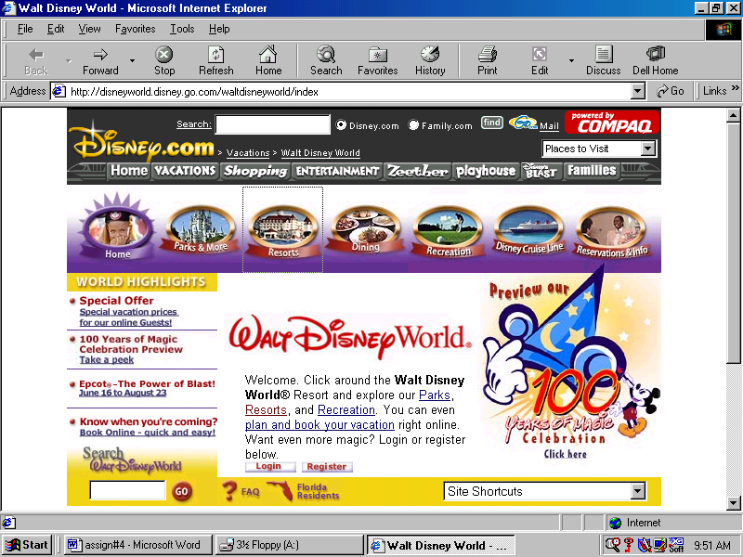
www.disneyworld.com This site is the Disney world site. It has many different links: such as a vacation link, resorts link, park link and so forth. I use this site for my children. They like to go out to this site to check out the Mickey Mouse activities that are going on.

